Bengaluru, Karnataka, India



AN INTERNSHIP REPORT ON

“ VTU SGPA CALCULATOR FOR VTU GATES ”

## BACHELOR OF ENGINEERING

In

#### COMPUTER SCIENCE AND ENGINEERING

##### Submitted by : NANDITHA A (1SB18CS051)

##### 

Sri Sairam College of Engineering

(Affiliated to Visvesvaraya Technological University and Approved by AICTE, New Delhi)Accredited By NAAC with ‘B’ Grade

An ISO 9001-2015 certified Institute

**Bengaluru, Karnataka 562106**

##### 2020-2021

**ABOUT THE COMPANY**

CST is a digital service provider that aims to provide software, designing and marketing solutions to individuals and businesses. At CST , we believe that service and quality is the key to success

We provide all kinds of technological and designing solutions from Billing Software to Web Designs or any custom demand that you may have. Experience the service like none other!

Some of our services include:

* Development - We develop responsive, functional and super-fast websites.
* We keep User Experience in mind while creating websites. A website should load quickly and shouldbe accessible even on a small view-port and slow internet connection.
* Mobile Application - We offer a wide range of professional Android, iOS& Hybrid app development services for our global clients, from a start up to a large enterprise.
* Design - We offer professional Graphic design, Brochure design & Logo design. We are expertsin crafting visual content to convey the right message to the customers.
* Consultancy - We are here to provide you with expert advice on your design and development requirement.
* Videos - We create a polished professional video that impresses your audience.

# Table of Contents

#### Contents Page No.

**Table of Contents I**

Overview of the project 1

About 2

Tools used 3

Implementation 4-7

SnapShots 8

Bibliography 9

##### (I)

### OVERVIEW OF THE PROJECT

**Project Name**: VTU SGPA CALCULATOR FOR VTU GATES

This project is based on Web Development and its Applications. The main objective of this project is to learn the implementation of HTML, CSS and JavaScript at frontend and PHP, MySQL database at backend, The webpage of this project is created using HTML and styling of the webpage is done using CSS.

It is a web application that simplifies the task of storing a user’s results. The system is flexible to be used and reduces the need of frequently searching and accessing an individual’s marks. The system is developed to provide an easy means for storing semester wise results. Individuals have to login and enter their marks in a form. They can then access the result and print it in a PDF format.

1. **USER MODULE**

This module is mainly dedicated to the candidates who are looking to store their result. They can log in into the system, via the credentials provided to them & once they are in, they have to enter their data by filling an online form. They can download the result from the same module, in PDF file format.

1. **ADMIN MODULE**

This module is maintained by the admin and only he/she can manage and have access to every account. Admin can add or delete the users as well. They can modify the functionalities of the system, too. Admin can also add users on the fly to the application to make the application full of new functionalities.

**SGPA Calculator**

SGPA calculator is used to calculate SGPA for engineering VTU students, we can calculate the semester grade points.

The VTU adopts absolute grading system wherein the marks are converted to grades, and every semester results will be declared with semester grade point average (SGPA) and Cumulative.

The SGPA is the ratio of sum of the product of the number of credits with the grade points scored by a student in all the courses taken by a student and the sum of the number of credits of all the courses undergone by a student, i.e.

SGPA (Si) = ∑(Ci x Gi) / ∑Ci

where Ci is the number of credits of the ith course and Gi is the grade point scored by the student in the ith course.

SGPA, which stands for Semester Grade Point Average is an evaluation method that highlights the semester wise performance of the student.

It can be calculated by simply adding all the credit points awarded for the subjects and then dividing it by the total credits allotted to that semester.

For example, in a total of 3 subjects, you scored the following grade points:

Subject 1: 8

Subject 2: 6

Subject 3: 7

The total credit for each subject is 10.

1. Now, first we will multiply, the grade point with the total credit point for each subject: Subject 1: 8*10 = 80 Subject 2: 6*10 = 60 Subject 3: 7*10 = 70

2. To calculate SGPA here, you need to add all these grade points and then divide it by the total credits, i.e.

Total grade points: 210 Total credits: 30

To get SGPA, divide grade points by total credits, =210/30 =7 SGPA

.

### TOOLS USED

**Software Requirements**

* + Visual Studio Code 2019.
  + Google Chrome or Microsoft Edge of latest version.
  + Front End: HTML, CSS, JS
  + Backend : Php, MySQL, Xampp
  + Linux 7.1 or Windows XP/7/8/10 OS or Mac OS

**Hardware Requirements**

* + Pentium 200-MHz computer with a minimum of 64 MB of RAM (128 MB of RAM recommended).
  + Monitor with a refresh rate of at least 40Hz for a smooth GUI experience (optional).

# IMPLEMENTATION

package com.example.prart.sgpacalc;

import android.content.Intent;

import android.support.v7.app.AppCompatActivity;

import android.os.Bundle;

import android.view.View;

import android.widget.ArrayAdapter;

import android.widget.Button;

import android.widget.Spinner;

import android.widget.Toast;

/*CREATED BY ASHISH ON 01-10-2019*/

public class MainActivity extends AppCompatActivity {

    Button buttonlaunch;

    @Override

    protected void onCreate(Bundle savedInstanceState) {

        super.onCreate(savedInstanceState);

        setContentView(R.layout.activity_main);

        String choices[] = {"Percentage to SGPA","SGPA to Percentage"};

        final Spinner spinner = findViewById(R.id.spinnerselect);

        ArrayAdapter<String> spinnerArrayAdapter = new ArrayAdapter<String>(this,   android.R.layout.simple_spinner_item, choices);

        spinnerArrayAdapter.setDropDownViewResource(android.R.layout.simple_spinner_dropdown_item); // The drop down view

        spinner.setAdapter(spinnerArrayAdapter);

        buttonlaunch = findViewById(R.id.buttonlaunch);

        buttonlaunch.setOnClickListener(new View.OnClickListener() {

            @Override

            public void onClick(View v) {

                final String selecteditem;

                selecteditem = spinner.getSelectedItem().toString();

                switch (selecteditem)

                {

                    case "Percentage to SGPA":

                        Intent intent;

                        intent = new Intent(getApplicationContext(),perc_to_sgpa.class);

                        startActivity(intent);

                        break;

                    case "SGPA to Percentage":

                        Intent intent1 = new Intent(getApplicationContext(),sgpa_to_perc.class);

                        startActivity(intent1);

                        break;

                     //default:

                    //     Toast.makeText(getApplicationContext(),"Default",Toast.LENGTH_SHORT).show();

                }

            }

        });

    }

}

package com.example.prart.sgpacalc;

import android.content.Intent;

import android.support.v7.app.AppCompatActivity;

import android.os.Bundle;

import android.view.View;

import android.widget.Button;

import android.widget.CompoundButton;

import android.widget.EditText;

import android.widget.Switch;

import android.widget.TextView;

import android.widget.Toast;

import static java.sql.Types.NULL;

public class perc_to_sgpa extends AppCompatActivity {

    private TextView result;

    private Button convert;

    EditText inputtext;

    Switch aSwitch;

    TextView heading,textfrom,textto;

    @Override

    protected void onCreate(Bundle savedInstanceState) {

        super.onCreate(savedInstanceState);

        setContentView(R.layout.activity_perc_to_sgpa);

        result = findViewById(R.id.textViewresult);

        convert = findViewById(R.id.buttonconvert);

        inputtext = findViewById(R.id.editTextinput);

        aSwitch = findViewById(R.id.switchinvert1);

        heading = findViewById(R.id.textViewheading);

        textfrom = findViewById(R.id.textViewfrom);

        textto = findViewById(R.id.textViewto);

        convert.setOnClickListener(new View.OnClickListener() {

            @Override

            public void onClick(View v) {

               final String pcinput;

                pcinput = inputtext.getText().toString();

                if(pcinput.isEmpty()){

                    Toast.makeText(getApplicationContext(),"Percentage cannot be empty!!",Toast.LENGTH_SHORT).show();

                    result.setText(null);

                }

                else if(Float.parseFloat(pcinput) > 100){

                    Toast.makeText(getApplicationContext(),"Percentage cannot exceed 100!!",Toast.LENGTH_SHORT).show();

                    result.setText(null);

                    inputtext.setText(null);

                }

                else {

                    float pcin;

                    pcin = Float.parseFloat(pcinput);

                    double calcresult;

                    calcresult = ((pcin/10)+0.75);

                    result.setText(String.valueOf(calcresult));

                    Toast.makeText(getApplicationContext(),"Result is ready",Toast.LENGTH_SHORT).show();

                }

            }

        });

        aSwitch.setOnCheckedChangeListener(new CompoundButton.OnCheckedChangeListener() {

            @Override

            public void onCheckedChanged(CompoundButton buttonView, boolean isChecked) {

                //Intent intent4=new Intent(getApplicationContext(),sgpa_to_perc.class);

                //startActivity(intent4);

                if(isChecked){

                    heading.setText("Enter SGPA To Be Converted To Percentage");

                    textfrom.setText("Enter SGPA::");

                    textto.setText("Percentage::");

                    inputtext.setText(null);

                    result.setText(null);

                    final String sgpain = inputtext.getText().toString();

                    if(sgpain.isEmpty()){

                        Toast.makeText(getApplicationContext(),"SGPA cannot be empty",Toast.LENGTH_SHORT).show();

                        result.setText(null);

                        //sgpa.setText(null);

                    }

                    else if(Float.parseFloat(sgpain)> 10){

                        Toast.makeText(getApplicationContext(),"SGPA cannot exceed 10",Toast.LENGTH_SHORT).show();

                        result.setText(null);

                        inputtext.setText(null);

                    }

                    else{

                        float sgpainp=Float.parseFloat(sgpain);

                        double percresult;

                        percresult = (sgpainp-0.75)*10;

                        result.setText(String.valueOf(percresult));

                        Toast.makeText(getApplicationContext(),"Result is ready",Toast.LENGTH_SHORT).show();

                    }

                }

                else {

                    heading.setText("Enter Percentage To Be Converted To SGPA");

                    textfrom.setText("Enter Percentage::");

                    textto.setText("SGPA::");

                    inputtext.setText(null);

                    result.setText(null);

                    final String pcinput;

                    pcinput = inputtext.getText().toString();

                    if(pcinput.isEmpty()){

                        Toast.makeText(getApplicationContext(),"Percentage cannot be empty!!",Toast.LENGTH_SHORT).show();

                        result.setText(null);

                    }

                    else if(Float.parseFloat(pcinput) > 100){

                        Toast.makeText(getApplicationContext(),"Percentage cannot exceed 100!!",Toast.LENGTH_SHORT).show();

                        result.setText(null);

                        inputtext.setText(null);

                    }

                    else {

                        float pcin;

                        pcin = Float.parseFloat(pcinput);

                        double calcresult;

                        calcresult = ((pcin/10)+0.75);

                        result.setText(String.valueOf(calcresult));

                        Toast.makeText(getApplicationContext(),"Result is ready",Toast.LENGTH_SHORT).show();

                    }

                }

            }

        });

    }

}

### SNAPSHOTS

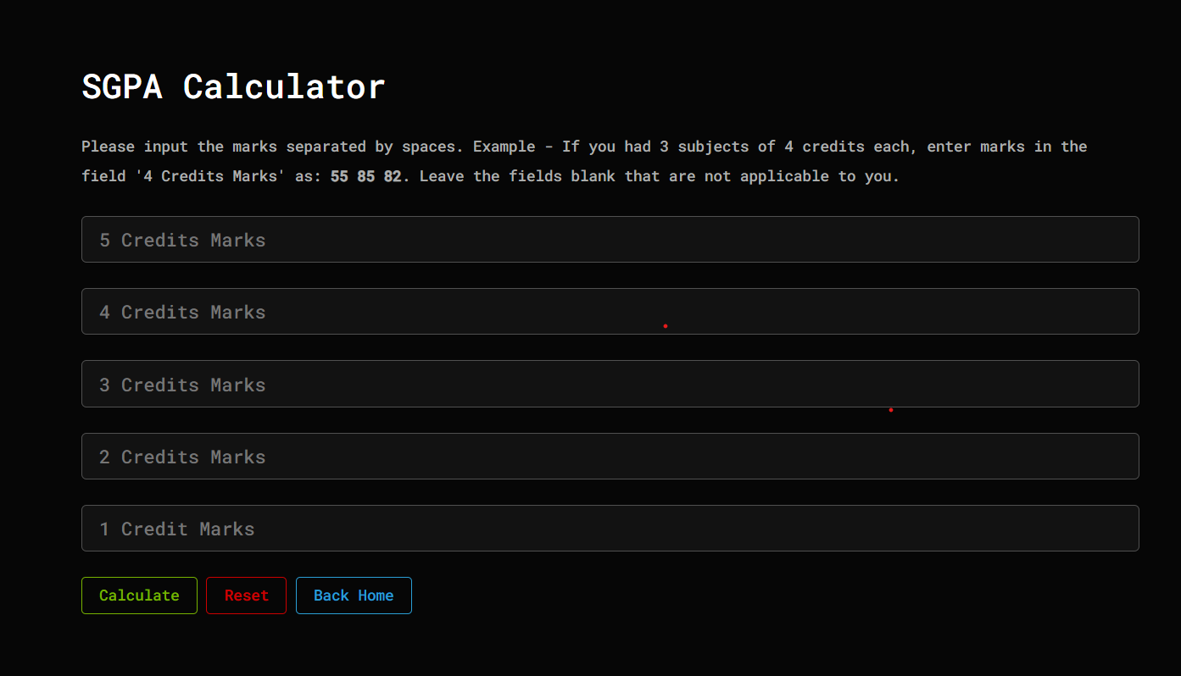

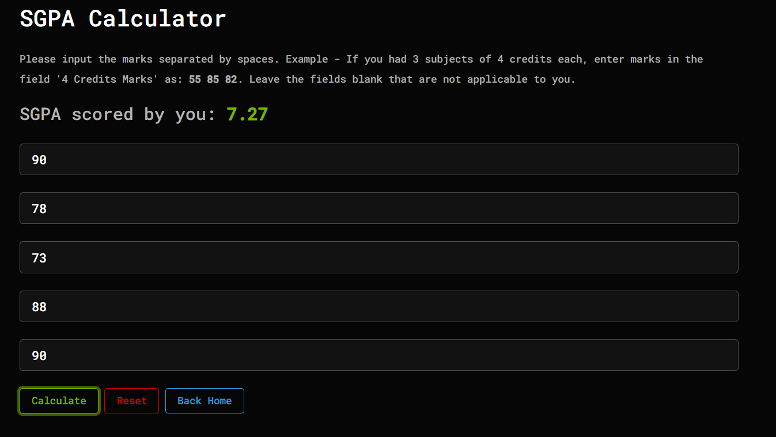

### BIBLIOGRAPHY

* https://[www.w3schools.com](http://www.w3schools.com/)
* https://www.geeksforgeeks org
* https://freefrontend.com
* <https://css-tricks.com/>
* https://www.takeiteasyengineers.com
* https://dev.to/mychi_darko/php-tips-and-tricks-4